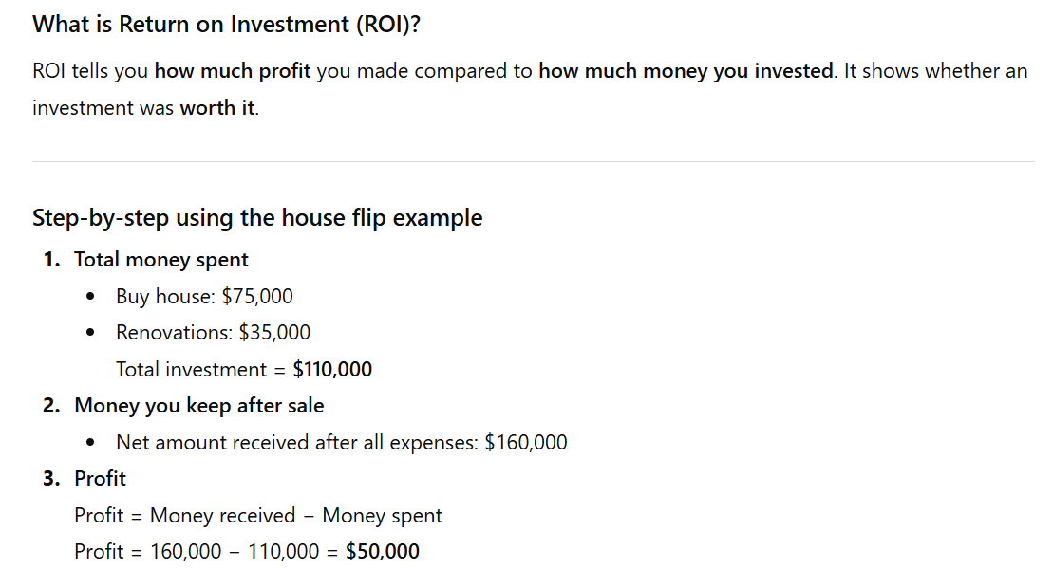
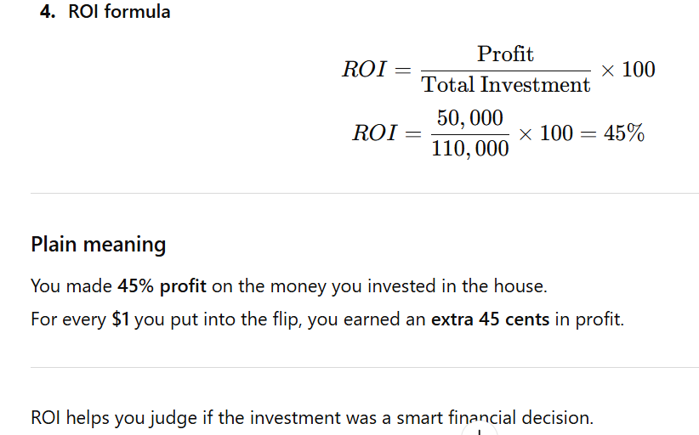

What does Discounted Cash Flow mean?
Discounted Cash Flow (DCF) is a method used to figure out how much future money is worth today. This is important because money today can earn interest or be invested, so it is more valuable than the same amount in the future.
This idea is called the time value of money.

Your Example Explained
You give someone Rs. 2,000 today.
They promise to return the money in 3 years.
You expect interest because your money is locked up and cannot grow anywhere else.
Interest rate: 5% per year
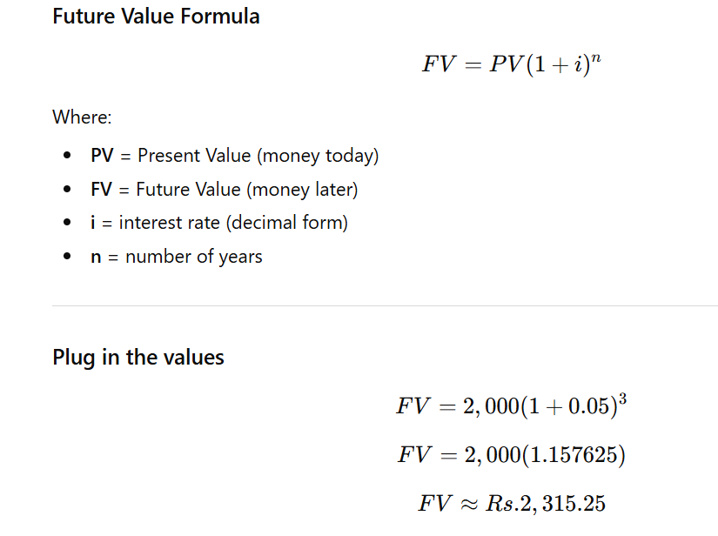
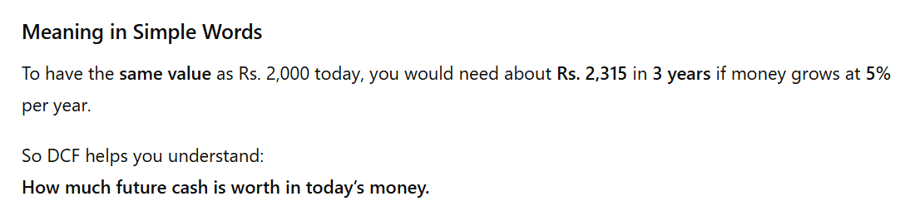
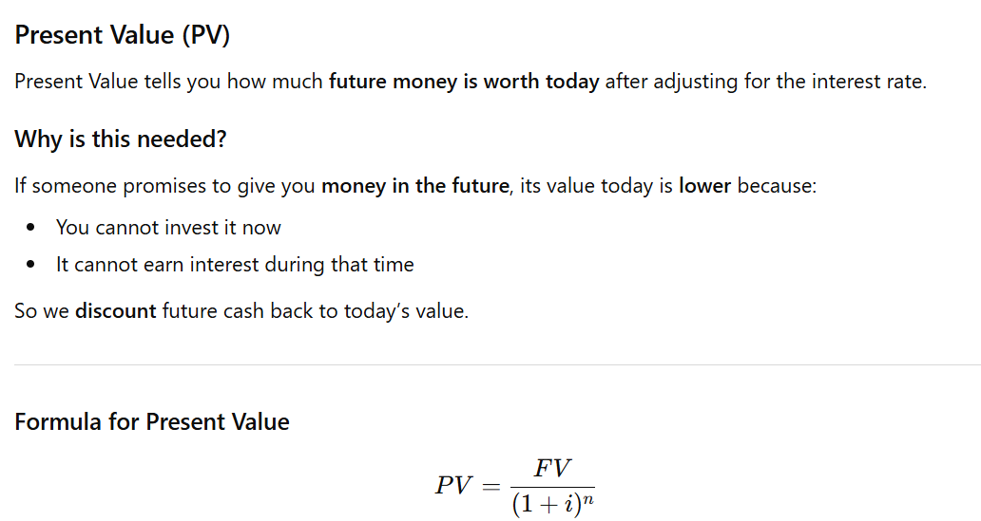
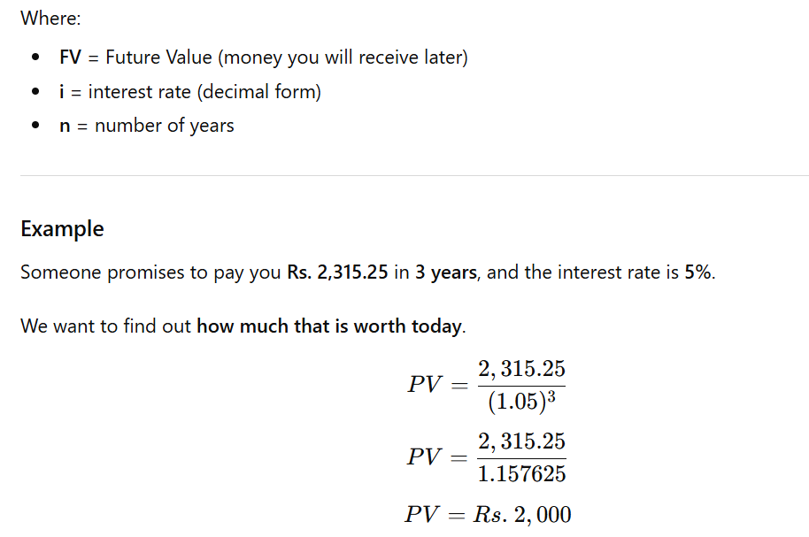
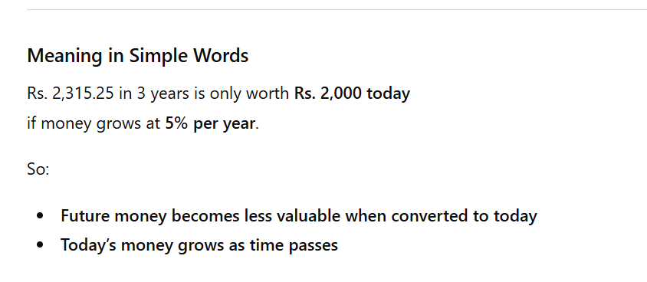

Here is another clear and simple Internal Rate of Return (IRR) example.

New Example
You invest $5,000 today.
You expect to receive $2,000 every year for 3 years.
Goal: Find the discount rate that makes NPV = 0.

